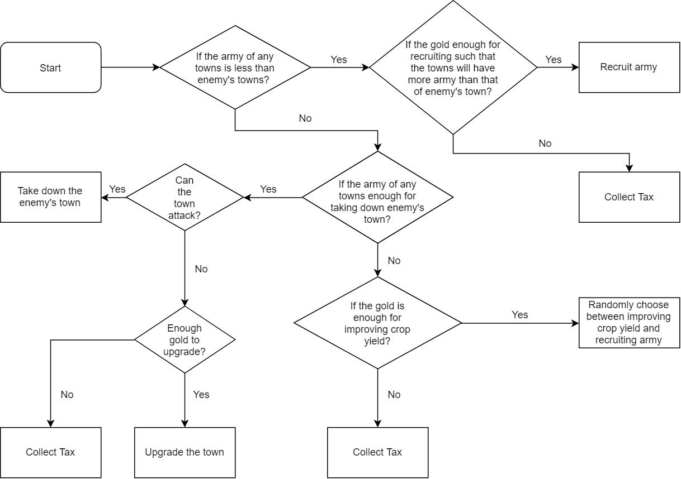

(The flow chart. Open the flow chart.jpg in the same folder to have a clear look.)

The function of the computer action is in **private** **void** processComputerPlayerTurn().

My idea is to make sure all the towns are safe first. Then see if there is any chance of taking down enemy’s towns. Notice that the part checking there is enough gold to recruit army and checking if there is enough army for taking down town, it will use the equation

targetVal = (**int**)(expeditionSize)*(general.getCombatPoint()/100f)) for checking the recruit army

and

targetVal = (**int**)(baseVal * (general.getCombatPoint() / 100f)) for checking the damage.

Also, I found a typo in the given function in the skeleton. In

**private** **void** updateListViewNeiItems(), there is a line:

listViewNeiItems.add(neiTown.name + " " + neiTown.population + " " + neiTown.armySize + " " + town.cropYield + " " + wall);

and I change it to

listViewNeiItems.add(neiTown.name + " " + neiTown.population + " " + neiTown.armySize + " " + neiTown.cropYield + " " + wall);

Therefore, my NeiView will be different from the sample executable jar.